Result of the Map6_with_barrier_4

Table

Map6_with_barrier
Angle degree | Robot_size | Route distance | Running time (s) | Coverage (%)
357 | 4 | 2833,42 | 99,21 | 80,74
358 | 4 | 2831,4 | 109,11 | 79,7
359 | 4 | 2501,46 | 103,83 | 80,13
0 | 4 | 2619,52 | 43,87 | 7,39
1 | 4 | 2521,02 | 71,82 | 77,71
2 | 4 | 2670,65 | 37,86 | 78,02
3 | 4 | 2455,47 | 36,62 | 77,01
43 | 4 | 2513,93 | 37,32 | 82,11
44 | 4 | 2682,72 | 39,69 | 81,1
45 | 4 | 2535,36 | 91,8 | 80,94
46 | 4 | 2497,37 | 41,91 | 80,95
47 | 4 | 2714,36 | 37,47 | 82,49
48 | 4 | 2581,23 | 41,5 | 81,78
87 | 4 | 2492,59 | 58,14 | 77,75
88 | 4 | 2582,42 | 141,14 | 78,19
89 | 4 | 2512,78 | 54,87 | 78,52
90 | 4 | 2478,63 | 58,69 | 78,27
91 | 4 | 2597,89 | 47,03 | 79,81
92 | 4 | 2562,1 | 51,38 | 78,98
93 | 4 | 2692,9 | 96,32 | 78,86
133 | 4 | 2590,9 | 35,08 | 81,93
134 | 4 | 2668,71 | 34,55 | 81,64
135 | 4 | 2544,52 | 34,47 | 80,2
136 | 4 | 2575,43 | 52,94 | 80,49
137 | 4 | 2522,52 | 94,76 | 80,18
138 | 4 | 2532,25 | 96,08 | 79,96
177 | 4 | 2931,89 | 39,12 | 82,61
178 | 4 | 2956,92 | 38 | 78,79
179 | 4 | 2519,85 | 35,75 | 78,95
180 | 4 | 2676,51 | 31,45 | 80,28
181 | 4 | 2564,05 | 45,43 | 78,05
182 | 4 | 2636,2 | 43,29 | 77,5
183 | 4 | 2624,67 | 49,41 | 77,48
223 | 4 | 2566,27 | 81,77 | 82,32
224 | 4 | 2610,19 | 40,76 | 81,79
225 | 4 | 2551,96 | 40,3 | 81,02
226 | 4 | 2630,63 | 81,74 | 79,66
227 | 4 | 2630,49 | 42,74 | 82,08
228 | 4 | 2745,85 | 79,55 | 82,05
267 | 4 | 2454,2 | 64,55 | 77,45
268 | 4 | 2604,46 | 58,11 | 79,15
269 | 4 | 2527,74 | 54,01 | 78,22
270 | 4 | 2486,66 | 67,3 | 77,61
271 | 4 | 2464,03 | 87,47 | 79,04
272 | 4 | 2556,97 | 51,39 | 78,37
273 | 4 | 2650,25 | 50,26 | 79,25

Blue color is the best result.
Red color is the best Horizontal/Vertical.
Green color is the Best approximate vertical/horizontal angle degrees.

Best result
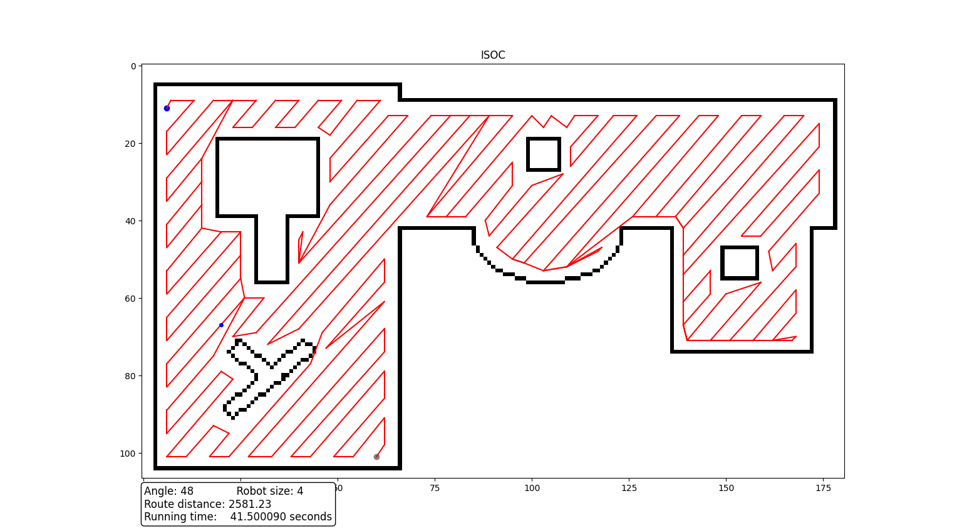
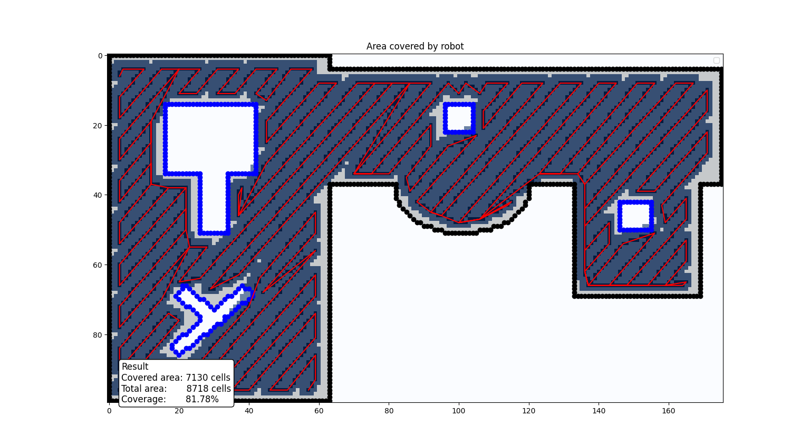


Best horizontal/vertical
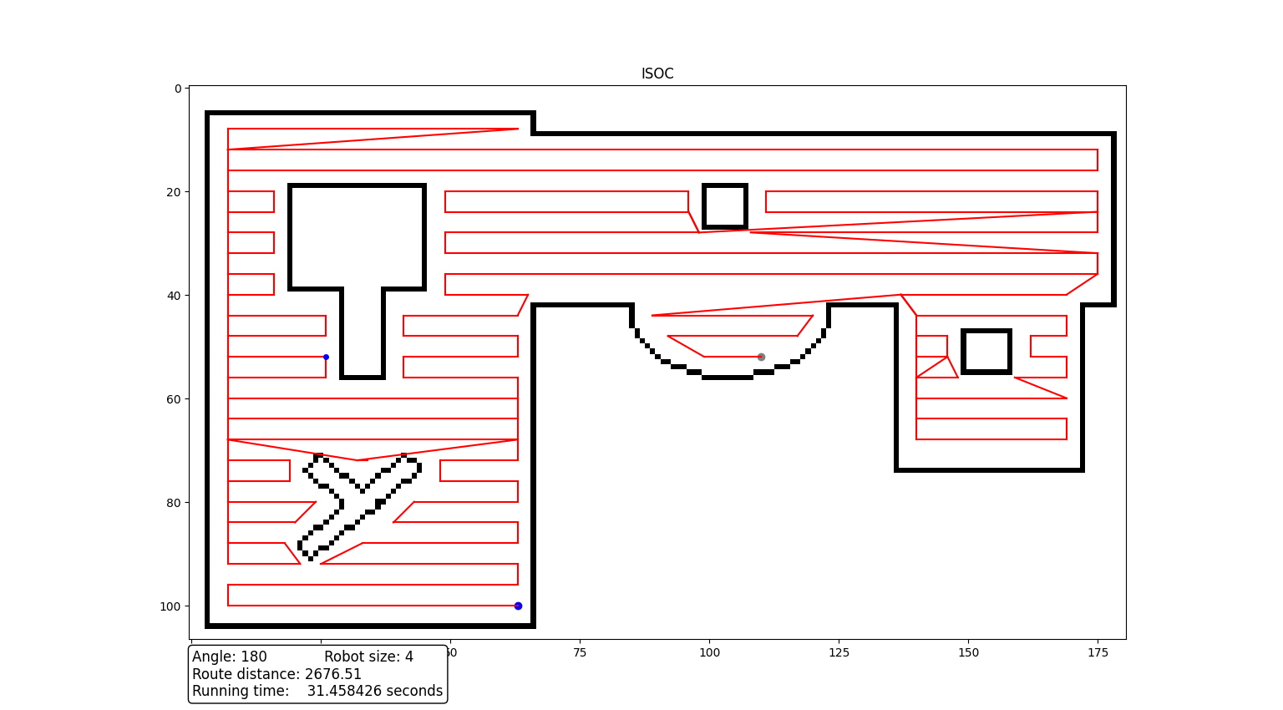
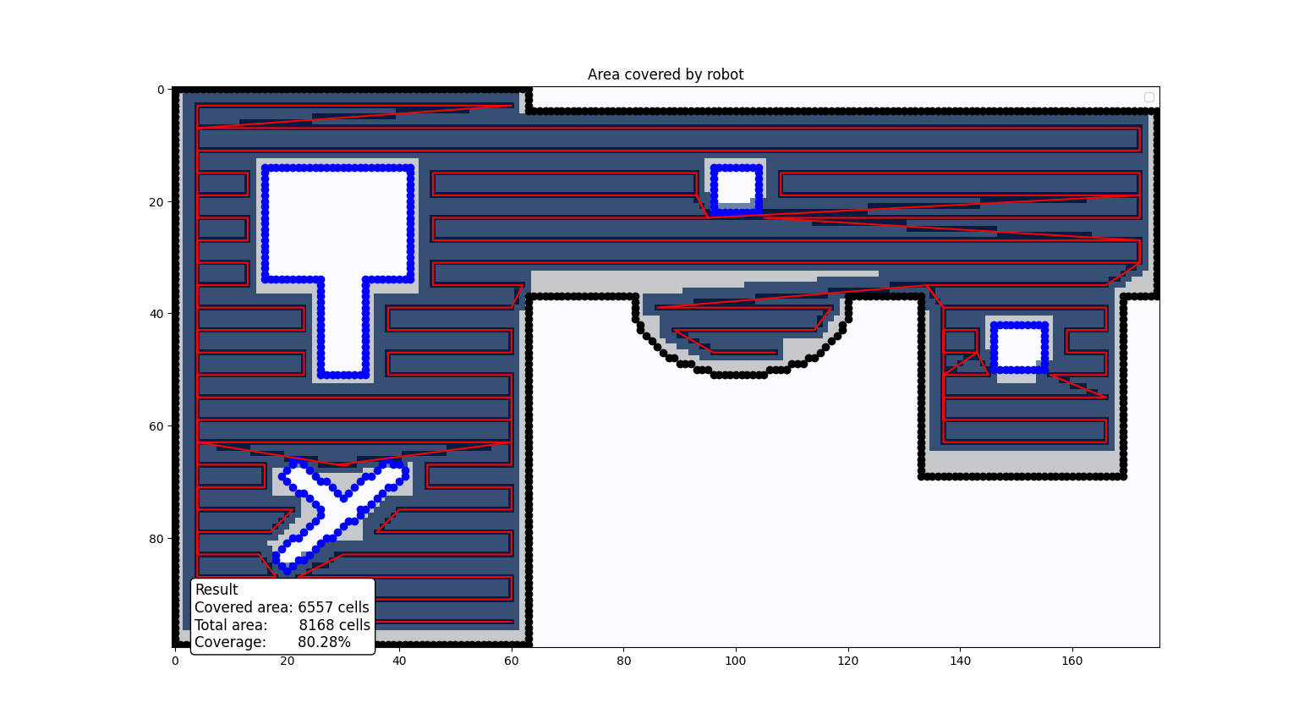

Best approximate vertical/horizontal angle degrees
